

U23CB593 SYSTEM DESIGN LABORATORY

DEPARTMENT OF ARTIFICIAL INTELLIGENCE AND DATA SCIENCE

SRI ESHWAR COLLEGE OF ENGINEERING KINATHUKADAVU COIMBATORE - 641202

DEPARTMENT OF ARTIFICIAL INTELLIGENCE AND DATA SCIENCE

BONAFIDE CERTIFICATE

Certified that this is the bonafide record of work done by

Name: Mr. /Ms. ...……………………………………………………………………………………. Register No: ……………………………………………………………………………... of 3rd Year B.E/B.Tech ……………………………………………………………………………... in the U23CB593 SYSTEM DESIGN LABORATORY during the 5th Semester of the academic year 2025 – 2026 (Odd Semester).

Signature of faculty In-charge Head of the department

Submitted for the practical examinations of Anna University, held on …………….

Internal Examiner External Examiner

Table of Contents

S.No | Date | Name of the Experiment | Page Number | Marks (50) | Signature of the Faculty Member
1 |  | Layered architecture diagram for a note-taking application using component diagrams
2 |  | The High Level Design (HLD) and Low Level Design (LLD) for a URL Shortening service (TinyURL
3 |  | The working of Redis cache for an API by explaining in- memory caching with TTL and LRU eviction policy
4 |  | Producer-Consumer system design using Kafka to demonstrate an order processing queue
5 |  | Design and compare SQL and NoSQL schema for a blogging platform, highlighting the concepts of  normalization and denormalization
6 |  | Implementation of Circuit Breaker and Retry Logic using Resilience4j
7 |  | Implementation of Token Bucket Rate Limiter
8 |  | Failover and Heartbeat Mechanisms in a Load-Balanced Application using Mock Services
9 |  | Implementation of Microservices for E-Commerce Checkout System using REST API
10 |  | Implementation of Pub/Sub Notification Service using RabbitMQ
11 |  | Demonstration of API Gateway Architecture using Express.js or NGINX
12 |  | Implementation of Real-Time Chat Application
13 |  | Implementation of servlet-based user management with CRUD operations.
14 |  | REST API architecture using Spring Boot or JAX-RS for a task management system.
15 |  | Implementation of Capstone System Design

Average:
Average (in words) Signature of the Faculty

Ex No : 1 | Layered architecture diagram for a note-taking application using component diagrams
Date:

Aim:
To draw a layered architecture diagram for a note-taking application using component diagrams and explain the data flow between client, server, and database.

Procedure:

- Determine the main components — client (UI), server (application logic), and database (data storage).
- Assign specific roles to each layer — Presentation, Application, Data Access, and Database.
- Represent each layer with components and connect them using arrows to show interactions.
- Describe how requests move from client to server and responses flow back after database operations.
- Ensure that all layers communicate properly and that the design supports scalability and maintenance.

Diagram:

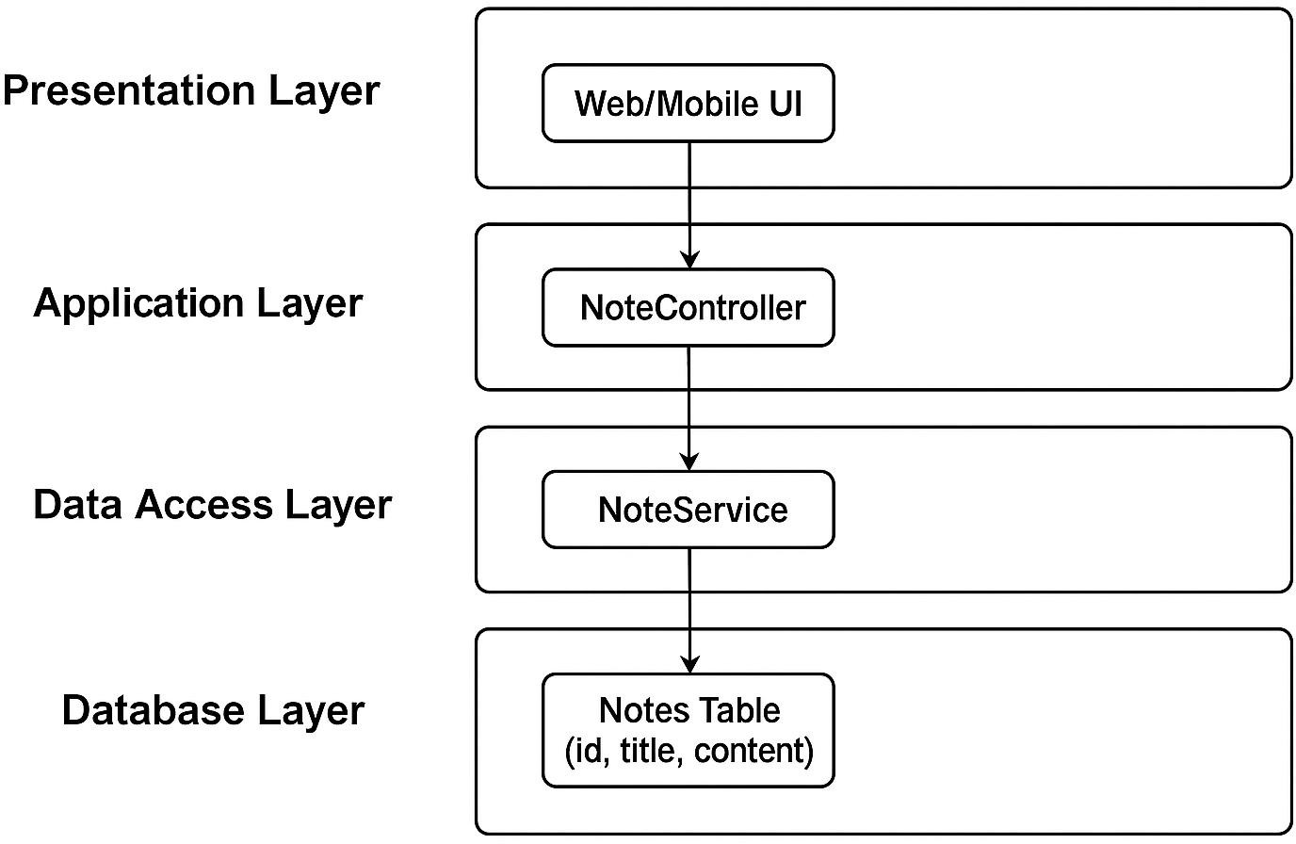

Explanation :

Client to Server:

  - The user interacts with the Presentation Layer (UI).
  - For example, when creating a new note, the user enters text and clicks “Save”.
  - The request (with note details) is sent to the NoteController in the server.

Server (Business Logic):

  - The NoteController forwards the request to the NoteService, which contains the business rules.
  - The NoteService validates the input and prepares it for database storage.

Server to Database:

  - The NoteService calls the NoteDAO (Data Access Object), which executes SQL queries or ORM commands.
  - The NoteDAO interacts with the Database Layer to insert, update, retrieve, or delete data.

Database to Server:

  - The Database Layer returns query results to the NoteDAO, which passes them to the NoteService, and then to the NoteController.

Server to Client:

  - The NoteController sends the response back to the UI.
  - The UI updates the display — showing confirmation (for create/delete) or updated notes (for read/edit).

Result :
Thus the layered architecture diagram for the Note-Taking Application was successfully designed and the data flow between the client, server, and database was explained.

Ex No : 2 | The High Level Design (HLD) and Low Level Design (LLD) for a URL Shortening service (TinyURL
Date:

Aim:
To Prepare High Level Design (HLD) and Low Level Design (LLD) for a URL Shortening service (TinyURL), including major components, database schema, and flow diagrams.

Procedure:

- Identify system components: API, Database, and Redirect Service.
- Define data flow for URL creation and redirection.
- Design database schema to store short and long URLs.
- Implement short code generation logic using Base62 encoding.
- Test URL creation and redirection with sample inputs.

Flow diagram:
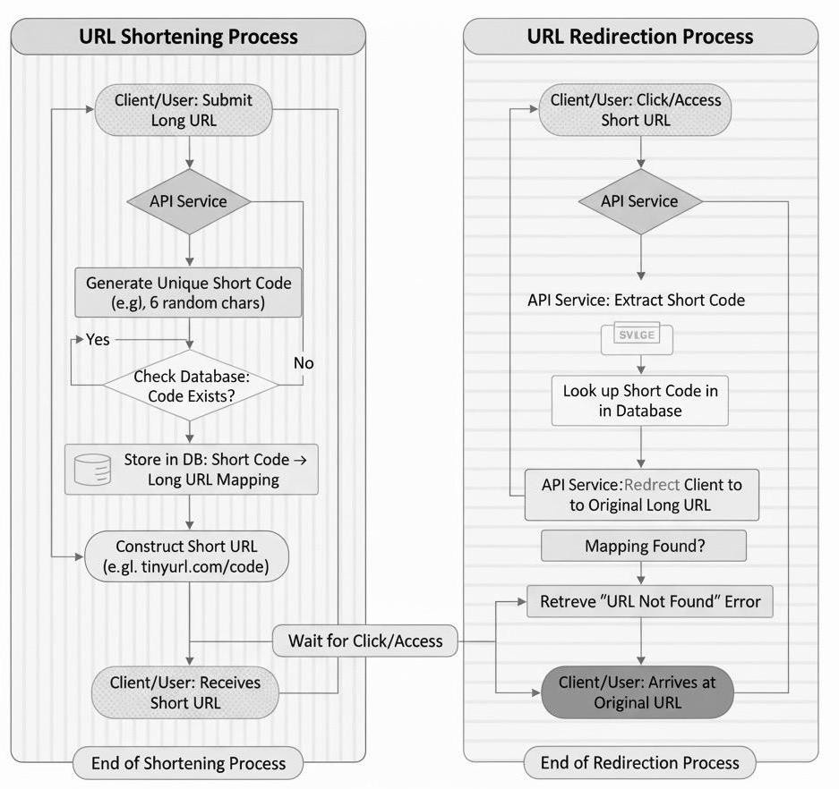

Database Schema:

Field Name | Type | Description
id | INT (PK) | Unique identifier
long_url | VARCHAR | Original URL
short_code | VARCHAR | Generated short code
created_at | TIMESTAMP | Creation time

Program:
import java.util.*;
import java.util.concurrent.ConcurrentHashMap;

public class URLShortener {
private static final String BASE_URL = "https://tinyurl.com/"; private static final String CHARSET =
"abcdefghijklmnopqrstuvwxyzABCDEFGHIJKLMNOPQRSTUVWXYZ0123456789"; private static final Map<String, String> urlMap = new ConcurrentHashMap<>();

public static String shortenURL(String longUrl) { String shortCode = generateCode(); urlMap.put(shortCode, longUrl);
return BASE_URL + shortCode;
}

public static String redirect(String shortCode) {
return urlMap.getOrDefault(shortCode, "URL not found");

}

private static String generateCode() { Random rand = new Random(); StringBuilder code = new StringBuilder(); for (int i = 0; i < 6; i++)
code.append(CHARSET.charAt(rand.nextInt(CHARSET.length()))); return code.toString();
}

public static void main(String[] args) {
String longUrl = "https://example.com/some/long/path"; String shortUrl = shortenURL(longUrl); System.out.println("Shortened: " + shortUrl);
System.out.println("Redirected to: " + redirect(shortUrl.substring(BASE_URL.length())));
}
}

Output :
Shortened: https://tinyurl.com/aB9kLp
Redirected to: https://example.com/some/long/path

Result :
Thus the High Level Design (HLD) and Low Level Design (LLD) for a URL Shortening service (TinyURL), including major components, database schema, and flow diagrams was successfully designed.

Ex No : 3 | The working of Redis cache for an API by explaining in-memory caching with TTL and LRU eviction policy
Date:

Aim:
To illustrate the working of Redis cache for an API by explaining in-memory caching with TTL (Time-To-Live) and LRU (Least Recently Used) eviction policy.

Procedure:
- Install Redis and connect it to your backend API (e.g., Node.js, Python Flask, or Django).
- The API endpoint fetches data (e.g., product details) from a database.
- Integrate Redis Cache:
  - Before querying the database, the API checks if the data exists in Redis.
  - If present, the cached data is returned (cache hit).
  - If not, data is fetched from the database and stored in Redis with a TTL.
- Configure Redis to use maxmemory-policy allkeys-lru so least recently used keys are deleted when memory is full.
- After TTL expires, the cache is cleared automatically, forcing the next request to fetch from DB again.

Program:
import redis.clients.jedis.Jedis;
import redis.clients.jedis.params.SetParams; import java.time.Instant;
import java.util.Random;
import java.util.concurrent.TimeUnit;

public class RedisCacheDemo {
// Simulated DB (slow) static class SlowDB {
String fetch(String key) {
try { TimeUnit.MILLISECONDS.sleep(200); } catch (InterruptedException ignored) {}
return "VALUE_FOR_" + key + "_at_" + Instant.now();
}
}
static class RedisCache { private final Jedis jedis; private final int ttlSeconds;
RedisCache(Jedis jedis, int ttlSeconds) { this.jedis = jedis;
this.ttlSeconds = ttlSeconds;
}
// Get value: Redis GET; fallback to DB fetch and SET with TTL String getOrLoad(String key, SlowDB db) {
String val = jedis.get(key); if (val != null) {
System.out.println("[CACHE HIT] " + key); return val;
} else {
System.out.println("[CACHE MISS] " + key + " -> loading from DB"); String fromDb = db.fetch(key);

// SET key with EX TTL atomically
SetParams params = new SetParams().ex(ttlSeconds); jedis.set(key, fromDb, params);
return fromDb;
}
}
// helper to display approximate memory usage and key info void printInfo() {
System.out.println("Redis INFO: " + jedis.info("memory").split("\n")[0]);
System.out.println("Current TTL of sample key (if exists): " + jedis.ttl("sample_key"));
}
}
public static void main(String[] args) {
// Adjust host/port if needed
try (Jedis jedis = new Jedis("localhost", 6379)) { System.out.println("Connected to Redis: " + jedis.ping());
// NOTE: Configure Redis server separately for LRU eviction:
// CONFIG SET maxmemory 20mb
// CONFIG SET maxmemory-policy allkeys-lru
RedisCache cache = new RedisCache(jedis, 5); // TTL = 5 seconds SlowDB db = new SlowDB();
// Warm some keys
System.out.println("\n--- Warm cache ---"); cache.getOrLoad("user:1001", db);

cache.getOrLoad("user:1002", db);
// Access pattern: simulate hits & misses System.out.println("\n--- Access pattern ---"); cache.getOrLoad("user:1001", db); // should be hit cache.getOrLoad("user:9999", db); // miss -> load
// Show TTL behaviour
System.out.println("\n--- TTL demonstration (wait for 6 seconds) ---"); try { Thread.sleep(6000); } catch (InterruptedException ignored) {} cache.getOrLoad("user:1001", db); // TTL expired -> miss and reload
// To trigger LRU eviction for demo, you would insert many large keys,
// exceeding maxmemory set in Redis server. Keys least recently used get evicted. System.out.println("\n--- LRU eviction note ---");
System.out.println("If Redis maxmemory is small, inserting many keys causes LRU eviction");
System.out.println("Server eviction policy (server-side): " + jedis.configGet("maxmemory-policy"));
cache.printInfo();
}
}
}

Output :
Connected to Redis: PONG
--- Warm cache ---
[CACHE MISS] user:1001 -> loading from DB [CACHE MISS] user:1002 -> loading from DB
--- Access pattern --- [CACHE HIT] user:1001
[CACHE MISS] user:9999 -> loading from DB
--- TTL demonstration (wait for 6 seconds) --- [CACHE MISS] user:1001 -> loading from DB
--- LRU eviction note ---
If Redis maxmemory is small, inserting many keys causes LRU eviction Server eviction policy (server-side): allkeys-lru
Redis INFO: # Memory
Current TTL of sample key (if exists): -2

Result :
Thus the working of Redis cache for an API by explaining in-memory caching with TTL (Time-To-Live) and LRU (Least Recently Used) eviction policy was successfully designed.

Ex No : 4 | Producer-Consumer system design using Kafka to demonstrate an order processing queue
Date:

Aim:
To Simulate a producer-consumer system design using Kafka to demonstrate an order processing queue.

Procedure:
- Start Kafka broker and create topic orders
- Implement a Java Producer that sends JSON order messages to orders.
- Implement a Java Consumer that listens to orders, processes each order and commits offsets (either auto or manual commit shown).
- Simulate multiple producers and multiple consumers (consumer group) to show scaling.

Program:
OrderProducer.java
import org.apache.kafka.clients.producer.*;
import org.apache.kafka.common.serialization.StringSerializer; import com.fasterxml.jackson.databind.ObjectMapper;
import java.util.Properties; import java.util.UUID; public class OrderProducer {
private final KafkaProducer<String, String> producer; private final String topic;
private final ObjectMapper mapper = new ObjectMapper(); public OrderProducer(String bootstrapServers, String topic) {
Properties props = new Properties();

props.put(ProducerConfig.BOOTSTRAP_SERVERS_CONFIG, bootstrapServers);
props.put(ProducerConfig.KEY_SERIALIZER_CLASS_CONFIG, StringSerializer.class.getName());
props.put(ProducerConfig.VALUE_SERIALIZER_CLASS_CONFIG, StringSerializer.class.getName());
// durability settings props.put(ProducerConfig.ACKS_CONFIG, "all"); props.put(ProducerConfig.RETRIES_CONFIG, 3); this.producer = new KafkaProducer<>(props); this.topic = topic;
}
public void sendOrder(Order order) throws Exception { String value = mapper.writeValueAsString(order);
// key by orderId ensures ordering per key partition
ProducerRecord<String, String> record = new ProducerRecord<>(topic, order.orderId, value);
producer.send(record, (metadata, exception) -> { if (exception != null) {
System.err.println("Failed to send order " + order.orderId); exception.printStackTrace();
} else {
System.out.printf("Sent order %s to partition %d offset %d%n", order.orderId, metadata.partition(), metadata.offset());
}
});
}

public void close() { producer.flush(); producer.close();
}
public static class Order { public String orderId; public String userId; public double amount; public String item; public long timestamp;
public Order(String userId, String item, double amount) { this.orderId = UUID.randomUUID().toString(); this.userId = userId;
this.item = item; this.amount = amount;
this.timestamp = System.currentTimeMillis();
}
}
// Simple main to send a few orders
public static void main(String[] args) throws Exception { OrderProducer p = new OrderProducer("localhost:9092", "orders"); for (int i = 0; i < 10; i++) {
Order o = new Order("user-" + (i%3), "item-" + i, 10.5 + i); p.sendOrder(o);
Thread.sleep(200);

}
p.close();
}
}

OrderConsumer.java
import org.apache.kafka.clients.consumer.*; import org.apache.kafka.common.TopicPartition;
import org.apache.kafka.common.serialization.StringDeserializer; import com.fasterxml.jackson.databind.ObjectMapper;
import java.time.Duration; import java.util.*;
public class OrderConsumer {
private final KafkaConsumer<String, String> consumer; private final String topic;
private final ObjectMapper mapper = new ObjectMapper();
public OrderConsumer(String bootstrapServers, String topic, String groupId) { Properties props = new Properties(); props.put(ConsumerConfig.BOOTSTRAP_SERVERS_CONFIG, bootstrapServers);
props.put(ConsumerConfig.KEY_DESERIALIZER_CLASS_CONFIG, StringDeserializer.class.getName());
props.put(ConsumerConfig.VALUE_DESERIALIZER_CLASS_CONFIG, StringDeserializer.class.getName());
props.put(ConsumerConfig.GROUP_ID_CONFIG, groupId);
// disable auto-commit to demonstrate manual commit (at-least-once behavior) props.put(ConsumerConfig.ENABLE_AUTO_COMMIT_CONFIG, "false"); props.put(ConsumerConfig.AUTO_OFFSET_RESET_CONFIG, "earliest");

this.consumer = new KafkaConsumer<>(props); this.topic = topic;
}
public void start() { consumer.subscribe(Collections.singletonList(topic)); System.out.println("Consumer started, waiting for orders..."); try {
while (true) {
ConsumerRecords<String, String> records = consumer.poll(Duration.ofMillis(1000));
if (records.isEmpty()) continue;
for (ConsumerRecord<String, String> rec : records) { try {
OrderProducer.Order order = mapper.readValue(rec.value(), OrderProducer.Order.class);
System.out.printf("Processing order %s from user %s amount=%.2f partition=%d offset=%d%n",
order.orderId, order.userId, order.amount, rec.partition(), rec.offset());
} catch (Exception e) {
System.err.println("Processing failed for record, skipping commit for this

batch");

e.printStackTrace();
}
}

// commit offsets after batch processing (manual commit) try {
consumer.commitSync();

System.out.println("Offsets committed");
} catch (CommitFailedException cfe) { System.err.println("Commit failed: " + cfe.getMessage());
}
}
} finally { consumer.close();
}
}
public static void main(String[] args) {
OrderConsumer c = new OrderConsumer("localhost:9092", "orders", "order- processors");
c.start();
}
}

Output :

Sent order 9b2b... to partition 1 offset 12
Processing order 9b2b... from user user-1 amount=11.50 partition=1 offset=12 Offsets committed

Result :
Thus a producer-consumer system design using Kafka to demonstrate an order processing queue was successfully designed.

Ex No : 5 | Design and compare SQL and NoSQL schema for a blogging platform, highlighting the concepts of normalization and denormalization
Date:

Aim:
To design and compare SQL and NoSQL schema for a blogging platform, highlighting the concepts of normalization and denormalization.

Procedure:

- Identify core blog entities: Users, Posts, Comments, Tags.
- Create relational SQL schema with foreign keys and normalized structure.
- Create NoSQL denormalized document structure for fast reads.
- Highlight advantages and disadvantages of both approaches.

Program:

SQL:
CREATE TABLE posts (
id BIGSERIAL PRIMARY KEY,
author_id BIGINT, title VARCHAR(255),
content TEXT
);
CREATE TABLE comments (
id BIGSERIAL PRIMARY KEY,
post_id BIGINT, comment TEXT
);

No-SQL:
{
"post_id": "p1", "title": "Hello World",
"content": "First post...", "comments": [
{ "user": "User1", "comment": "Nice!" }
]
}

Explanation:

Normalization (SQL)

- Data Integrity & Consistency: Each entity (Users, Posts, Comments, Tags) is stored separately and linked using foreign keys. This reduces redundancy and ensures consistent updates.
- Efficient Storage: Since repeated information (e.g., user details in every comment) is avoided, database storage is optimized.
- Complex Queries: Retrieving a blog post with its comments requires joins across multiple tables, which can slightly increase query complexity and read latency.

Denormalization (NoSQL)

- Improved Read Performance: All related data (post and comments) are stored within a single document, reducing the need for joins and enabling faster reads.
- Redundant Data Storage: Some data, like user details, may be repeated across documents, increasing storage usage.
- Simpler Reads, Complex Writes: Updating repeated data (e.g., user info) across multiple documents can be complex but read operations remain extremely efficient.

Result :
Thus the SQL and NoSQL schema for a blogging platform, highlighting the concepts of normalization and denormalization was successfully designed.

Ex No : 6 | Implementation of Circuit Breaker and Retry Logic using Resilience4j
Date:

Aim:
To implement and demonstrate Circuit Breaker and Retry logic in a microservice using Resilience4j to handle service failures gracefully and improve fault tolerance.

Procedure:
- Define the purpose of the Circuit Breaker — to prevent repeated calls to a failing service and protect the system from cascading failures.
- Configure the Circuit Breaker with parameters like failure rate threshold, wait duration in open state, and sliding window size.
- Define the Retry logic configuration with parameters such as maximum retry attempts and waiting duration between retries.
- Create a simulated remote service call that may fail randomly to test the fault-tolerance behavior.
- Wrap the service call using Resilience4j decorators that combine both Circuit Breaker and Retry logic.
- Execute multiple service requests and observe how the Circuit Breaker opens after consecutive failures and retries occur automatically.
- Verify that after the wait duration, the Circuit Breaker moves to the half-open state, allowing limited test requests before closing again upon success.

Diagram:
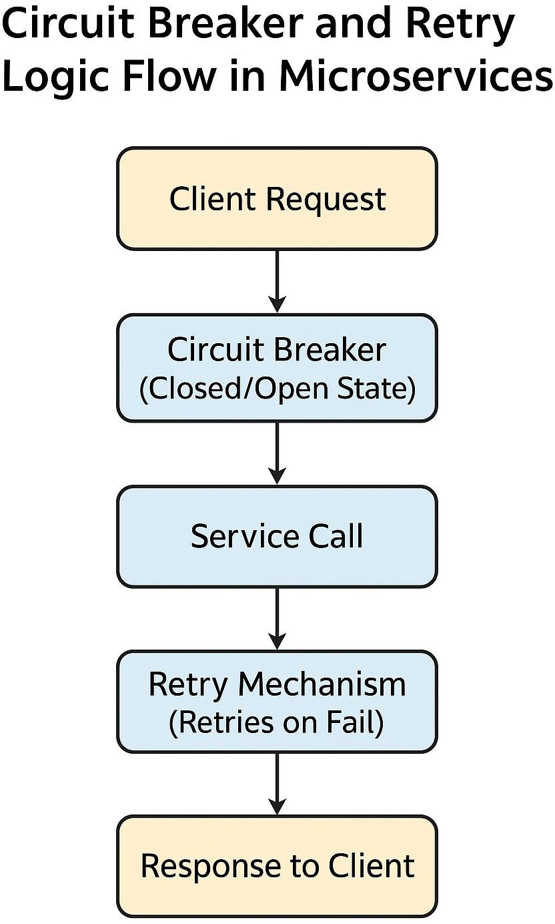

Program :
// ServiceCaller.java
import io.github.resilience4j.circuitbreaker.*; import io.github.resilience4j.retry.*;
import io.github.resilience4j.decorators.Decorators; import java.util.function.Supplier;
public class ServiceCaller {
public static void main(String[] args) throws Exception {
// Create CircuitBreaker configuration
CircuitBreakerConfig circuitBreakerConfig = CircuitBreakerConfig.custom()
.failureRateThreshold(50)
.waitDurationInOpenState(java.time.Duration.ofSeconds(5))
.slidingWindowSize(5)
.build();
CircuitBreaker circuitBreaker = CircuitBreaker.of("myCircuitBreaker", circuitBreakerConfig);
// Create Retry configuration
RetryConfig retryConfig = RetryConfig.custom()
.maxAttempts(3)
.waitDuration(java.time.Duration.ofSeconds(1))
.build();
Retry retry = Retry.of("myRetry", retryConfig)
// Simulated remote service call Supplier<String> remoteService = () -> {
System.out.println("Attempting remote service call..."); if (Math.random() < 0.7) { // 70% chance of failure
throw new RuntimeException("Service failed!");
}

return "Success Response from Service";
};
// Combine CircuitBreaker and Retry
Supplier<String> decoratedSupplier = Decorators.ofSupplier(remoteService)
.withCircuitBreaker(circuitBreaker)
.withRetry(retry)
.decorate();
for (int i = 1; i <= 10; i++) { try {
String result = decoratedSupplier.get(); System.out.println("Request " + i + ": " + result);
} catch (Exception e) {
System.out.println("Request " + i + ": " + e.getMessage());
}
Thread.sleep(1000);
}
}
}

Output :

Attempting remote service call... Request 1: Service failed!
Attempting remote service call... Request 2: Service failed!
Attempting remote service call... Request 3: Service failed!

CircuitBreaker is now OPEN - blocking further calls
Request 4: CircuitBreaker 'myCircuitBreaker' is OPEN and does not permit further calls Request 5: CircuitBreaker 'myCircuitBreaker' is OPEN and does not permit further calls (After 5 seconds)
Attempting remote service call...
Request 6: Success Response from Service CircuitBreaker is now CLOSED again Request 7: Success Response from Service

Result :
Thus, the Circuit Breaker and Retry mechanisms were successfully implemented using Resilience4j in Java to improve system resilience and handle transient failures gracefully in microservice communication.

Ex No : 7 | Implementation of Token Bucket Rate Limiter
Date: | Implementation of Token Bucket Rate Limiter

Aim:
To implement and demonstrate a Token Bucket Rate Limiter in Java to control the rate of incoming API requests.

Procedure:
- Define the maximum capacity of the token bucket (number of tokens it can hold).
- Define the rate at which tokens are refilled (tokens per second).
- For each incoming request, check if a token is available in the bucket.
- If a token is available, allow the request and consume one token.
- If the bucket is empty, reject the request (rate limit exceeded).
- Continuously refill tokens at the defined rate in the background.

Program :

// TokenBucketRateLimiter.java
public class TokenBucketRateLimiter { private final long capacity;
private final long refillRatePerSec; private double tokens;
private long lastRefillTimestamp;
public TokenBucketRateLimiter(long capacity, long refillRatePerSec) { this.capacity = capacity;
this.refillRatePerSec = refillRatePerSec; this.tokens = capacity;
this.lastRefillTimestamp = System.nanoTime();
}
private void refill() {
long now = System.nanoTime();
double tokensToAdd = ((now - lastRefillTimestamp) / 1_000_000_000.0) * refillRatePerSec;

tokens = Math.min(capacity, tokens + tokensToAdd); lastRefillTimestamp = now;
}
public synchronized boolean allowRequest() { refill();
if (tokens >= 1) { tokens--; return true;
}
return false;
}
public static void main(String[] args) throws InterruptedException {
TokenBucketRateLimiter limiter = new TokenBucketRateLimiter(5, 2); // 5 tokens max, 2/sec refill
for (int i = 1; i <= 10; i++) {
if (limiter.allowRequest()) { System.out.println("Request " + i + " allowed ");
} else {
System.out.println("Request " + i + " rejected - Rate limit exceeded");
}
Thread.sleep(400);}
}
}

Output :

Request 1 allowed
Request 2 allowed
Request 3 allowed
Request 4 allowed
Request 5 allowed
Request 6 rejected - Rate limit exceeded Request 7 rejected - Rate limit exceeded Request 8 allowed
Request 9 allowed
Request 10 allowed

Result :
Thus, a Token Bucket Rate Limiter was successfully implemented in Java to control and monitor the rate of incoming API requests.

Ex No : 8 | Failover and Heartbeat Mechanisms in a Load-Balanced Application using Mock Services
Date:

Aim:
To simulate and understand the working of failover and heartbeat mechanisms in a load- balanced system, ensuring service availability when one or more servers fail.

Procedure:
- Define MockService class with attributes: name and isAlive, methods: sendHeartbeat(), failService() and recoverService().
- Cfine loadBalancer class that maintains a list of services, monitors their heartbeats, routes requests to the active(healthy) service, performs failover by switching to another service when one fails.
- Implement the Main program; In the Failover class, create two mock services(Service A and Service B)
- Initialize the LoadBalancer with these services, run a loop that calls checkHeartbeats() to monitor health, routeRequest() to route traffic, randomly stimulate failure and recovery events, pauses between cycles using Thread.sleep().
- Compile and run the program, observe the console output showing normal operation, failure detection, automatic failover to the backup service, recovery and restoration of service.

Program :

// Failover.java import java.util.*;

class MockService { String name;
boolean isAlive = true;

MockService(String name) { this.name = name;
}

void sendHeartbeat() { if (isAlive) {
System.out.println(name + " heartbeat: ALIVE ");
} else {
System.out.println(name + " heartbeat: FAILED ");
}
}

void failService() { isAlive = false;
System.out.println(name + " has FAILED!");
}
void recoverService() { isAlive = true;
System.out.println(name + " has RECOVERED!");
}
}
class LoadBalancer { List<MockService> services; MockService activeService;

LoadBalancer(List<MockService> services) { this.services = services;
this.activeService = services.get(0);
}

void checkHeartbeats() {
for (MockService s : services) { s.sendHeartbeat();
}
}

void routeRequest() {
if (!activeService.isAlive) {
System.out.println(activeService.name + " is down. Switching to backup service...");
for (MockService s : services) { if (s.isAlive) {
activeService = s;
System.out.println("Now routing to: " + activeService.name); break;
}
}
} else {
System.out.println("Routing request to: " + activeService.name);
}
}
}

public class Failover {
public static void main(String[] args) throws InterruptedException {

MockService serviceA = new MockService("Service A"); MockService serviceB = new MockService("Service B");
LoadBalancer lb = new LoadBalancer(Arrays.asList(serviceA, serviceB)); for (int i = 1; i <= 6; i++) {
System.out.println("\n--- Cycle " + i + " ---"); lb.checkHeartbeats();
lb.routeRequest();

// Simulate random failure/recovery if (i == 3) serviceA.failService();
if (i == 5) serviceA.recoverService();

Thread.sleep(1000);
}
}
}

Output :

--- Cycle 1 ---
Service A heartbeat: ALIVE Service B heartbeat: ALIVE Routing request to: Service A

--- Cycle 2 ---
Service A heartbeat: ALIVE Service B heartbeat: ALIVE Routing request to: Service A

--- Cycle 3 ---
Service A has FAILED! Service A heartbeat: FAILED Service B heartbeat: ALIVE
Service A is down. Switching to backup service... Now routing to: Service B
--- Cycle 4 ---
Service A heartbeat: FAILED Service B heartbeat: ALIVE Routing request to: Service B

--- Cycle 5 ---
Service A has RECOVERED! Service A heartbeat: ALIVE Service B heartbeat: ALIVE Routing request to: Service B

--- Cycle 6 ---
Service A heartbeat: ALIVE Service B heartbeat: ALIVE Routing request to: Service B

Result :
Thus, a Failover and Heartbeat mechanism was successfully implemented in Java using mock services to ensure continuous availability and automatic recovery in a load- balanced application.

Ex No: 9 | Implementation of Microservices for E-Commerce Checkout System using REST API
Date:

Aim:
To design and implement microservices for an e-commerce checkout system using REST API concepts.

Procedure:
- Define the core microservices — Cart, Payment, and Inventory.
- Design RESTful APIs for each service with clear endpoints and data formats.
- Create separate databases for independent operation of each service.
- Implement inter-service communication using REST API calls.
- Ensure error handling and data consistency during checkout.
- Test the complete checkout process for correct integration.

Program:

@RestController class CartService {
@PostMapping("/cart/add")
public String addToCart(String product, int quantity) { return quantity + " " + product + " added to cart";
}
}
@RestController
class PaymentService { @PostMapping("/payment/process")

public String processPayment(double amount) { return "Payment of $" + amount + " successful";
}
}
@RestController
class InventoryService { @GetMapping("/inventory/check")
public String checkStock(String product) { return "Stock available for " + product;
}
}
@SpringBootApplication public class ECommerceApp {
public static void main(String[] args) { SpringApplication.run(ECommerceApp.class, args);
}
}

Output:
Cart 2: Shoes added to cart
Payment: Payment of $100 successful. Inventory: Stock available for Shoes

Result:
Microservices for e-commerce checkout were successfully implemented using REST APIs.

Ex No: 10 | Implementation of Pub/Sub Notification Service using RabbitMQ
Date:

Aim:
To implement and demonstrate a Publish/Subscribe Notification Service in Java using RabbitMQ that triggers events upon user registration.

Procedure:
- Install and configure RabbitMQ server on the local system.
- Add RabbitMQ Java client library to the project.
- Create a Producer class that publishes a message when a new user registers.
- Create a Consumer class that listens to the message queue.
- Connect both producer and consumer to the same queue using RabbitMQ connection.
- Verify that the consumer receives the event when a user registers.

Program:

UserRegistrationProducer.java:
import com.rabbitmq.client.Channel; import com.rabbitmq.client.Connection;
import com.rabbitmq.client.ConnectionFactory; public class UserRegistrationProducer {
private final static String QUEUE_NAME = "user_notifications"; public static void main(String[] args) throws Exception {
ConnectionFactory factory = new ConnectionFactory(); factory.setHost("localhost");
try (Connection connection = factory.newConnection(); Channel channel = connection.createChannel()) {
channel.queueDeclare(QUEUE_NAME, false, false, false, null); String message = "New user registered: Kirtick"; channel.basicPublish("", QUEUE_NAME, null, message.getBytes()); System.out.println(" [x] Sent: " + message);
}
}

}

UserNotificationConsumer.java:
import com.rabbitmq.client.*;
public class UserNotificationConsumer {
private final static String QUEUE_NAME = "user_notifications"; public static void main(String[] argv) throws Exception {
ConnectionFactory factory = new ConnectionFactory(); factory.setHost("localhost");
Connection connection = factory.newConnection(); Channel channel = connection.createChannel();
channel.queueDeclare(QUEUE_NAME, false, false, false, null); System.out.println(" [*] Waiting for messages..."); DeliverCallback deliverCallback = (consumerTag, delivery) -> {
String message = new String(delivery.getBody(), "UTF-8"); System.out.println(" [x] Received notification: " + message);
};
channel.basicConsume(QUEUE_NAME, true, deliverCallback, consumerTag ->
{});
}
}

Output :

Producer Terminal:
[x] Sent: New user registered: Arun

Consumer Terminal:
[*] Waiting for messages...
[x] Received notification: New user registered: Arun

Result:
Thus, a Pub/Sub Notification Service was successfully implemented in Java using RabbitMQ.

Ex No : 11 | Demonstration of API Gateway Architecture using Express.js or NGINX
Date:

Aim:
To design and demonstrate an API Gateway architecture using Express.js or NGINX that routes incoming client requests to multiple backend services.

Procedure:
- Set up an API Gateway using Express.js or NGINX to handle client requests.
- Configure routing rules for different backend services (e.g., /user, /orders, /products).
- Forward requests to the appropriate backend service based on the route.
- Each backend service processes the request and returns the response to the Gateway.
- The Gateway aggregates or forwards responses back to the client.
- Optionally, implement authentication, logging, and load balancing at the Gateway level.
Diagram:
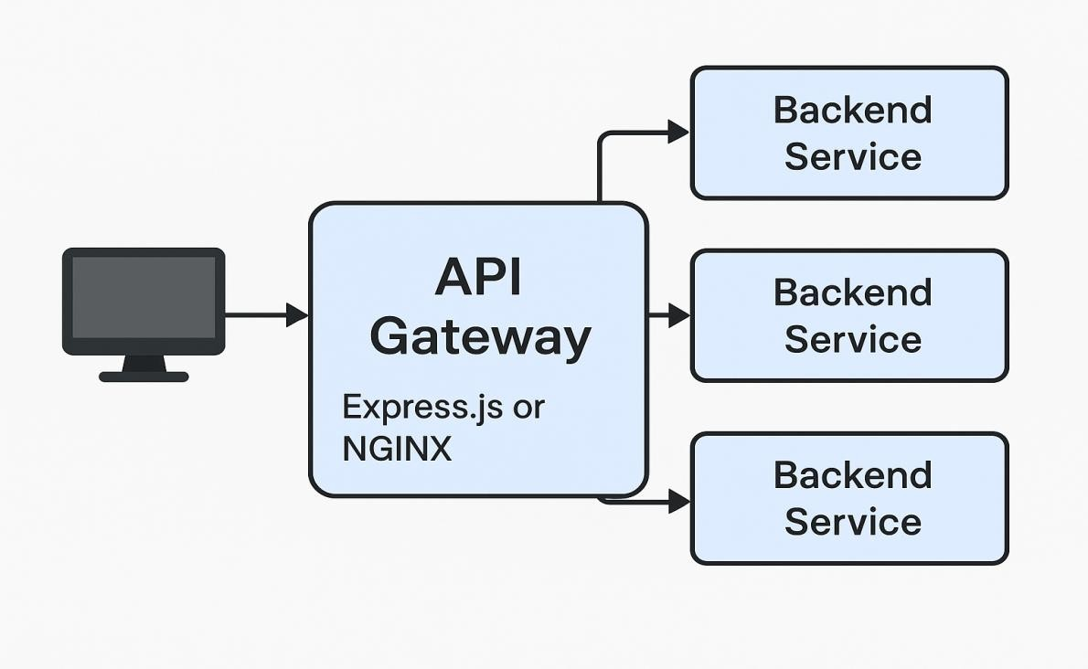

Program :

// api-gateway.js
const express = require('express'); const app = express();
const PORT = 3000;

// Route to User Service app.get('/users', (req, res) => { res.send('Routed to User Service');
});

// Route to Order Service app.get('/orders', (req, res) => { res.send('Routed to Order Service');
});

// Route to Product Service app.get('/products', (req, res) => { res.send('Routed to Product Service');
});

// Default route app.get('/', (req, res) => {
res.send('Welcome to API Gateway');
});

app.listen(PORT, () => {
console.log(`API Gateway running on port ${PORT}`);
});

Output :

API Gateway running on port 3000

Result :
Thus, an API Gateway architecture was successfully designed using Express.js or NGINX to route client traffic to multiple backend services efficiently.

Ex No : 12 | Implementation of Real-Time Chat Application
Date: | Implementation of Real-Time Chat Application

Aim:
To design a scalable chat system using WebSockets, message queues, and databases for reliable real-time communication.

Procedure:
- Initialize Node.js and Express.js project.
- Install dependencies: express, mongoose, socket.io, cors, dotenv, jsonwebtoken, bcryptjs.
- Setup React frontend using create-vite or create-react-app.
- Install React dependencies: axios, react-router-dom, socket.io-client, tailwind or material-ui.
- Create MongoDB cluster and connect using Mongoose.
- Define schemas for Users, Messages, and Chat Rooms.
- Configure Express server with middleware (CORS, JSON parsing).
- Implement REST APIs for user authentication and chat retrieval.
- Integrate Socket.io for real-time communication.
- Design frontend UI (Login, Signup, Chat Dashboard, Message Window, User List).
- Connect frontend to backend using Axios and WebSockets.
- Implement real-time message updates and event handling.
- Test multi-browser real-time functionality.
- Deploy frontend on Vercel/Netlify and backend on Render/Railway/AWS.

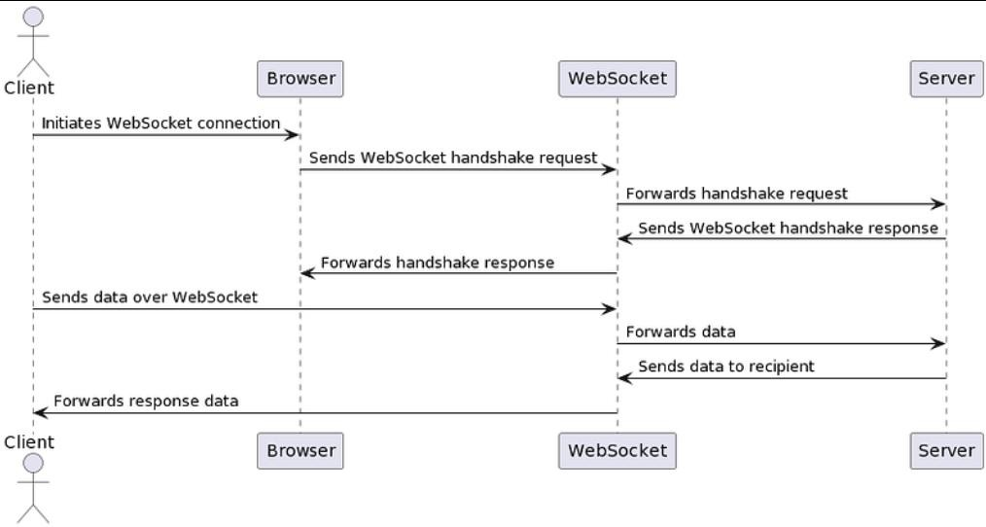
Diagram:

Result :
The design a scalable chat system using WebSockets, message queues, and databases has been successfully designed.

Ex No : 13 | Implementation of servlet-based user management with CRUD operations.
Date:

Aim:
To develop a Servlet-based User Management Application that performs CRUD (Create, Read, Update, Delete) operations on user data using Java Servlets, JSP, and JDBC.

Procedure:
- Create a database userdb with table users(id, name, email, country).
- Create a Java Servlet project and configure JDBC connection.
- Create:
  - User.java – Model class
  - UserDAO.java – Handles DB CRUD operations
  - UserServlet.java – Controls request/response
- Create JSP pages – user-form.jsp and user-list.jsp.
- Configure servlet in web.xml and run on Tomcat.

Program :

// User.java
package model; public class User {
private int id; private String name; private String email;
private String country;

public User(int id, String name, String email, String country) { this.id = id;
this.name = name; this.email = email; this.country = country;
}

public User(String name, String email, String country) { this.name = name;

this.email = email; this.country = country;
}

// Getters and Setters
public int getId() { return id; }
public String getName() { return name; } public String getEmail() { return email; } public String getCountry() { return country; }

public void setId(int id) { this.id = id; }
public void setName(String name) { this.name = name; } public void setEmail(String email) { this.email = email; }
public void setCountry(String country) { this.country = country; }
}

//UserDAO.java
import java.sql.*; import java.util.*; public class UserDAO {
Connection getCon() throws Exception { return
DriverManager.getConnection("jdbc:mysql://localhost:3306/userdb","root","password");
}
public void insert(User u)throws Exception{ PreparedStatement ps=getCon().prepareStatement("insert into users(name,email,country)values(?,?,?)");
ps.setString(1,u.name);ps.setString(2,u.email);ps.setString(3,u.country);ps.executeUpdate ();
}
public List<User> getAll()throws Exception{ List<User> list=new ArrayList<>();
ResultSet rs=getCon().createStatement().executeQuery("select * from users"); while(rs.next())list.add(new User(rs.getInt(1),rs.getString(2),rs.getString(3),rs.getString(4)));
return list;
}
}

//UserServlet.java @WebServlet("/")

public class UserServlet extends HttpServlet { UserDAO dao=new UserDAO();
protected void doGet(HttpServletRequest r,HttpServletResponse s)throws IOException,ServletException{
try{
List<User> list=dao.getAll(); r.setAttribute("list",list); r.getRequestDispatcher("user-list.jsp").forward(r,s);
}catch(Exception e){e.printStackTrace();}
}
protected void doPost(HttpServletRequest r,HttpServletResponse s)throws IOException{ try{dao.insert(new User(r.getParameter("name"),r.getParameter("email"),r.getParameter("country"))); s.sendRedirect("list");}catch(Exception e){e.printStackTrace();}
}
}

Output :
- User List Page
ID | Name | Email | Country | Actions

- | John | john@gmail.com | India | Edit | Delete
- | Alice | alice@yahoo.com | USA | Edit | Delete

Add / Edit Form
Name: [ ]
Email: [ ] Country: [ ] [Save] [Cancel] Result :
Thus, a Servlet-based User Management Application was successfully developed and implemented in Java using JSP, Servlets, and JDBC to perform and manage CRUD operations on user data efficiently.

Ex No : 14 | REST API architecture using Spring Boot or JAX-RS for a task management system.
Date:

Aim:
To design and implement a RESTful API architecture for a Task Management System using Spring Boot.

Procedure:
- Define models: Task, User, Project.
- Use Spring Boot with JPA for data persistence.
- Implement Controller → Service → Repository layers.
- Provide CRUD operations for tasks.
- Add a Token Bucket Rate Limiter filter for API request control.

Program :
//Entity @Entity
public class Task {
@Id @GeneratedValue private Long id; private String title;
private String description; private String status;
}

//Repository
public interface TaskRepository extends JpaRepository<Task, Long> {}
//Service

@Service
public class TaskService {
@Autowired private TaskRepository repo;

public List<Task> getAll() { return repo.findAll(); } public Task create(Task t) { return repo.save(t); }
}
//Controller @RestController
@RequestMapping("/api/tasks") public class TaskController {
@Autowired private TaskService service;

@GetMapping public List<Task> getAll() { return service.getAll(); }
@PostMapping public Task create(@RequestBody Task t) { return service.create(t); }
}
//Rate Limiter Filter @Component
public class TokenBucketFilter extends OncePerRequestFilter { private int tokens = 5; // capacity

@Override
protected void doFilterInternal(HttpServletRequest req, HttpServletResponse res, FilterChain chain)
throws IOException, ServletException {

if (tokens > 0) { tokens--; chain.doFilter(req, res); }
else { res.setStatus(429); res.getWriter().write("Rate limit exceeded"); }
}
}

Output :
GET /api/tasks [
{ "id": 1, "title": "Design API", "description": "Prepare task endpoints", "status": "TODO" }
]
POST /api/tasks
{ "id": 2, "title": "Implement service", "description": "Add business logic", "status": "IN_PROGRESS" }

Result :
Thus, A simple REST API for task management is successfully designed and implemented using Spring Boot, supporting CRUD operations and protected by a Token Bucket Rate Limiter.

Ex No : 15 | Implementation of Capstone System Design
Date: | Implementation of Capstone System Design

Aim:
To design a scalable Twitter-like platform focusing on database sharding, feed generation, and caching to efficiently handle millions of users and real-time data.

Procedure:

- Divide user data across multiple database shards using a hash-based sharding strategy.
- Implement feed generation using a hybrid approach — fan-out-on-write for regular users and fan-out-on-read for celebrity users.
- Use Redis caching to store recent tweets and timelines for quick retrieval.
- Employ message queues (e.g., Kafka) for background fan-out and timeline updates.
- Use an API Gateway for handling user requests and directing them to appropriate services.

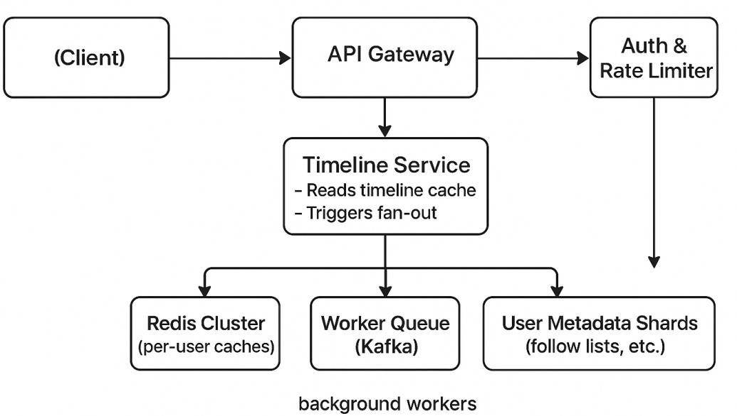
Diagram:
Result :
Thus A Twitter-like system was successfully designed that uses database sharding for scalability, Redis caching for fast timeline retrieval, and hybrid feed generation for efficient performance and reduced latency.

